MOBILE ENTREPRENEURSHIP FOR SUSTAINABLE FUTURE mPreneur

Call for Applications for the
mPreneur National Camp Austria
Linz, September 2022

Deadline for Application: 05th of September 2022, 23:59 CET
via email mpreneur.apply@ict4d.at

Coordinating Organization:

ICT4D.at
Austrian Network for Information and Communication Technologies for Development
Bertegasse 3, 1230 Wien, Austria
Website: https://ict4d.at
Email: mpreneur@ict4d.at

Partners / supporters:

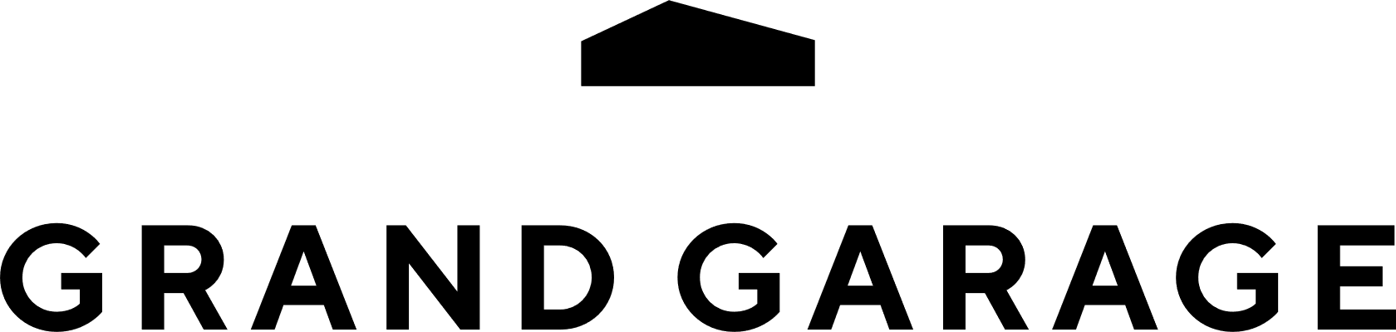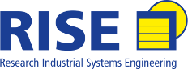

CoderDojo Linz Grand Garage Linz INSO RISE

INSTRUCTIONS
The Project “mPreneur: Youth Mobile Entrepreneurship for Sustainable Future” aims to stimulate capacity-building of youth and youth CSOs for usage of apps coding and ICT as vital skills for youth employability as well as for strengthening community resilience, developing innovative mobile solutions to the persisting community challenges. Social mobile entrepreneurship is recognized as a special concept uniting the purpose-driven component of the businesses and the mobile technology used. mPreneur does not only stimulate skills sharing among youngsters, but strengthens the quality of youth work by building CSOs capacities for digital learning and usage of ICT for youth empowerment and employability, while gamifying the process through mobile app business competitions.

Please read carefully through the Call for Application before filling out this mPreneur - Mobile Entrepreneurship for Sustainable Future Form. The Call for Application highlights the background of the mPreneur project, the eligibility criteria, the benefits and other important information. Ensure that you answer all the questions to your best and more importantly, be brief, precise and to the point for clarity and at the same time include important details about your mobile app. Observe the character limits, formatting style and any other instructions provided. NOTE that any incomplete applications will be automatically disqualified. Please send your completed application to mpreneur.apply@ict4d.at not later than 05th of September 2022, 23:59 CET. Applications delivered outside the deadline will automatically be disqualified.
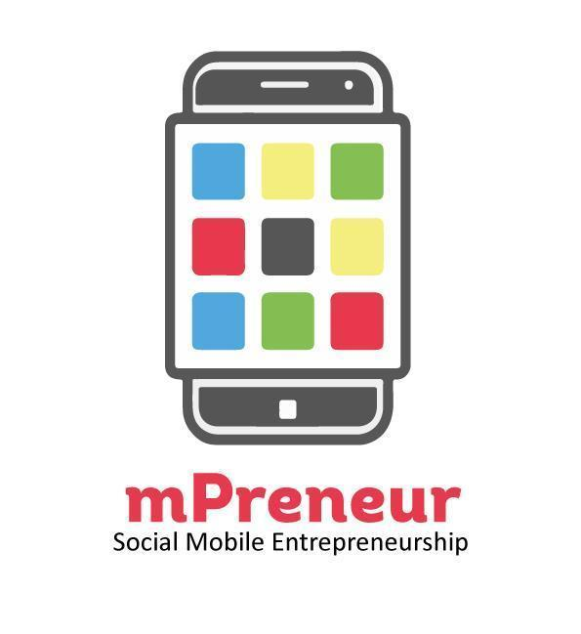

The mPreneur project is particularly dedicated to provide space for youth that is already in the field of new technologies and develop further their potentials by providing them with new ways of personalized, learner-centered, situated, collaborative, ubiquitous, and lifelong learning.
http://www.myouth.eu

APPLICANT INFORMATION

Contact Information of applying individuals/or group co-founders
Name of Mobile Solution/App
Full Name of the applicant
Date of Birth (dd/mm/yyyy)
Team Name / Organization (If applicable)
Website Address (if applicable)
E-mail Address
Phone of Contact Person
Postal Address
City
App Link (if applicable)

Are you an Austrian resident?
☐Yes
☐No

Organization type. Type of applying organization (tick as appropriate)

☐Individual
☐Nonformal Group
☐Company

☐Social Business
☐Non-Governmental Organization
☐Other please specify ______________

If you have a co-founder/ team member(s), kindly list their names, date of birth and email addresses.
Full Name | Date of Birth  dd/mm/yyyy | Email | Expertise e.g Programming, Design, business | Fluency in English  (yes/no)

In not more than 150 words, kindly give a brief description of your mobile app. What is your mobile app about?

What are the Target Groups/Beneficiaries/Users of your App? In this section, you are required to indicate the population that your mobile app is reaching. Let us clearly understand your target market (s) (not more than 100 words)

What is the Social Impact of your App? In not more than 250 words, how will your mobile app affect the lives of the beneficiaries/your target group? Kindly demonstrate what will be the social impact of your mobile app. Please give examples. We are interested on the mobile apps that will improve the wellbeing of the users/beneficiaries.

Development Stage of the Mobile App
Is your mobile app/solution in beta version / pre-launch version / uploaded on App Store/Google Play? | ☐Beta version  ☐Pre-launch Version  ☐Uploaded online
If your app is in Beta version, do you consent to complete it and make it available to users by October 2022? | ☐Yes  ☐No
Is your mobile app open for public view? | ☐Yes  ☐No

Problem definition: In not more than 100 words, what is the problem? What needs/challenges do these target groups face that your mobile app is addressing.

Needs Assessments: In not more than 100 words, what needs assessment have you conducted, and what were the findings? How did you identify these needs and challenges above?

Result and impact: In not more than 100 words, describe how the mobile app is addressing the problem described above? In which way your app is contributing in solving the problems detected?

Competition: What is your competitive advantage?

Creativity and Innovation. How is your mobile application/technology truly innovative and unique in your context? What makes your mobile app stand out? Bring out the value preposition.

Sustainability. What strategies have/will you put in place to ensure that the benefits of this mobile app continue to be felt now and beyond? How does your mobile app generate income?

If selected, do you or someone from your team consent to participate further on the National Camp, Training Course and World Summit Award Competition?
☐Yes
☐No

What is your motivation to apply for this competition? (Not more than 100 words)

Please share links to platforms that represent your mobile App online. This includes website, Facebook, Instagram, LinkedIn, Play Store, etc.?

Attachments. Applicant must attach a maximum of five screenshots of the mobile app operation demo to this application.

Thank you for your application!

Please provide the application form on
email mpreneur.apply@ict4d.at not later than 05th of September 2022, 23:59 CET

